**Project II Proposal**

**Topic:** Geographical Demonstration of Novel Coronavirus in the United States: Dashboard and Racing Chart

**Importance:**

The rapid evolving and widespread of COVID-19 has impacted the health and wealth of millions of families in the United States. As of June 30, 2020, more than 2.6 million individuals have been diagnosed with COVID-19 in the United States, and greater than 121,000 lives were lost within a few months. To help mitigate the health impact of COVID-19, Congress passed many health and economic policies. However, the risk of second wave is becoming preeminent, and it is important to visualize the geographical variations of COVID-19 for policy makers to make additional efforts to fight the pandemic in the coming months.

**Dataset:**

***COVID-19 data: Johns Hopkins University COVID-19 (***[***https://coronavirus.jhu.edu/us-map***](https://coronavirus.jhu.edu/us-map)***);   
This data is publicly available at github:*** [***https://github.com/CSSEGISandData/COVID-19***](https://github.com/CSSEGISandData/COVID-19)

***Data Sample (COVID-19 Confirmed Cases)***

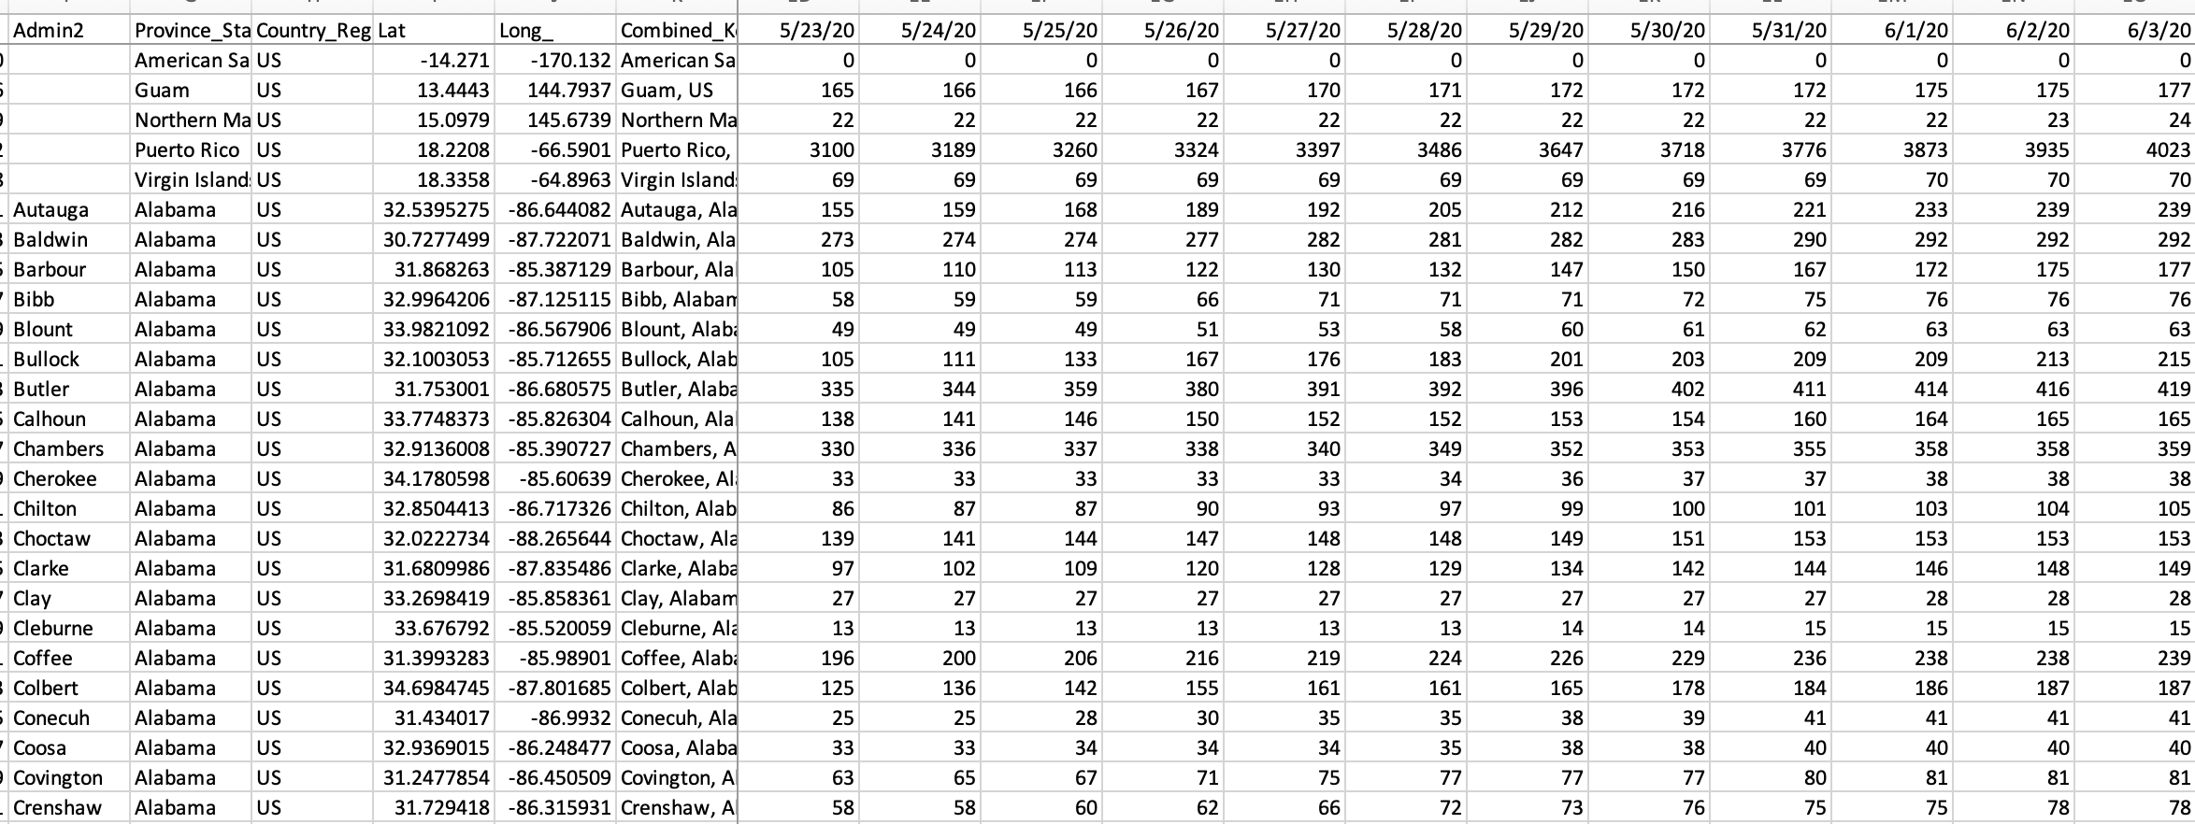

***Data Sample (COVID-19 Death Cases)***

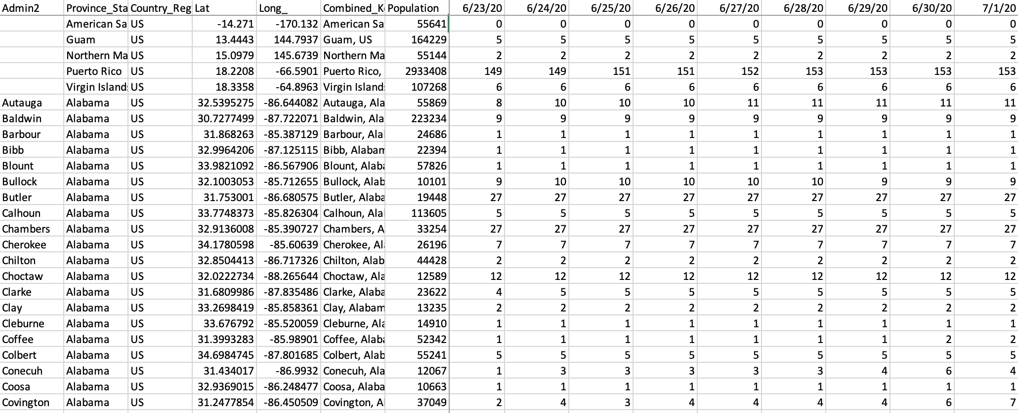

**Inspiration for project:**

We decided to create a dashboard to visualize the coronavirus cases in the United States, taking inspiration from other websites such as 1point3acres and Johns Hopkins.

**Proposed visualizations:**

We will use state level COVID-19 data (i.e. infection, hospitalization, and mortality) to create an interactive United States map on the front page. A drop- down menu with direct access to each specific state that is selected.

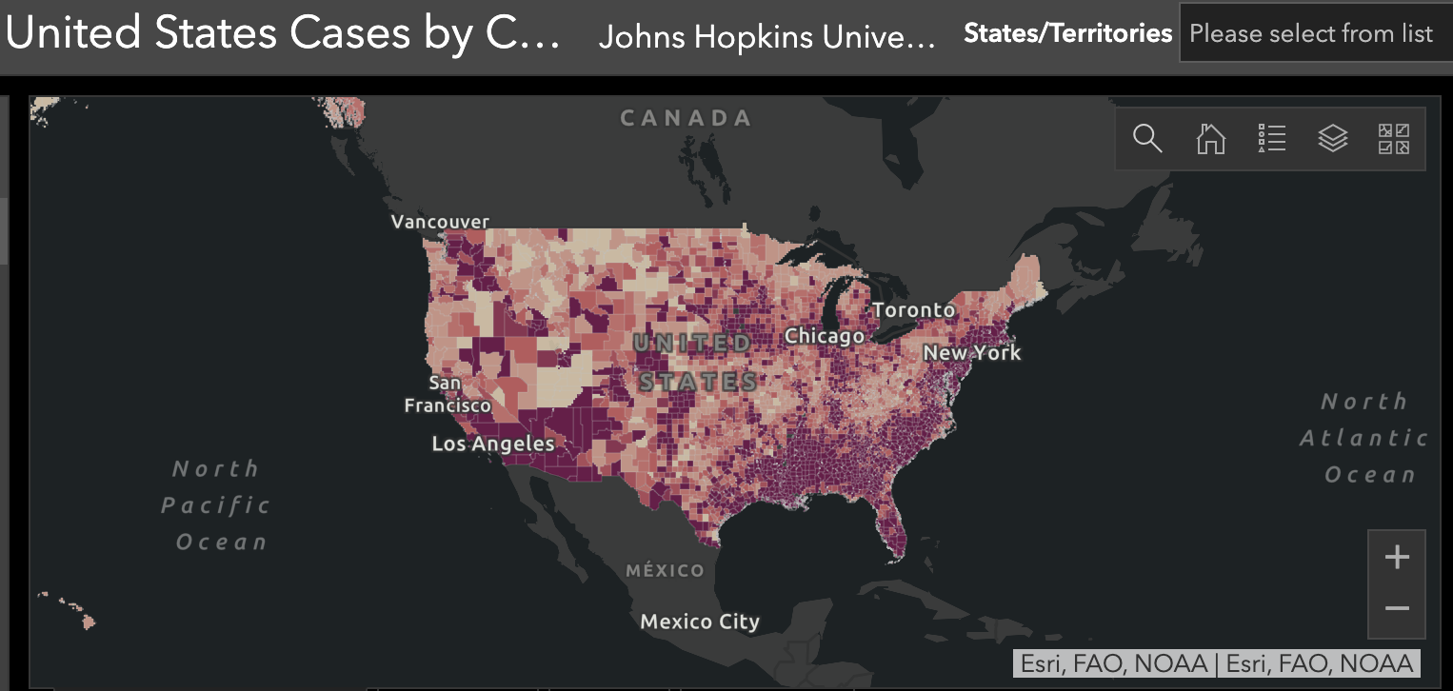

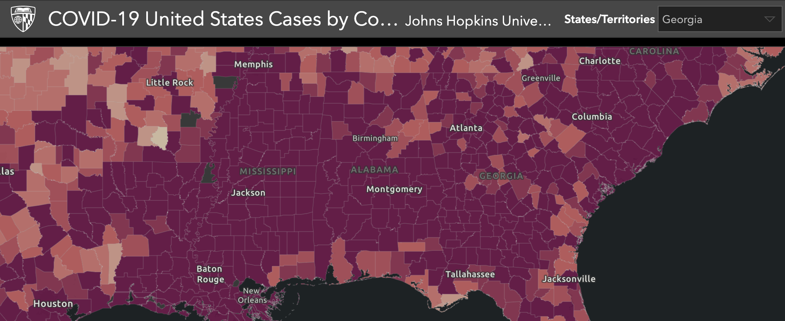

We will make use of **Fusion chart**, which is a JavaScript library to create a chart for visualization. We also propose to create a bar chart race that shows the increase in the number of cases/deaths over a period of time at state level. Through this, we would be able to visualize the progressions and changes of incidences of COVID-19 and the worst hit states since the beginning of the outbreak, highlighting the shift of epicenters from north to south over time with regards to the various measures that each state took, and the timeline they followed for reopening. We will create a bar chart race similar to the following example of “best global brands” (<https://observablehq.com/@d3/bar-chart-race-explained>):

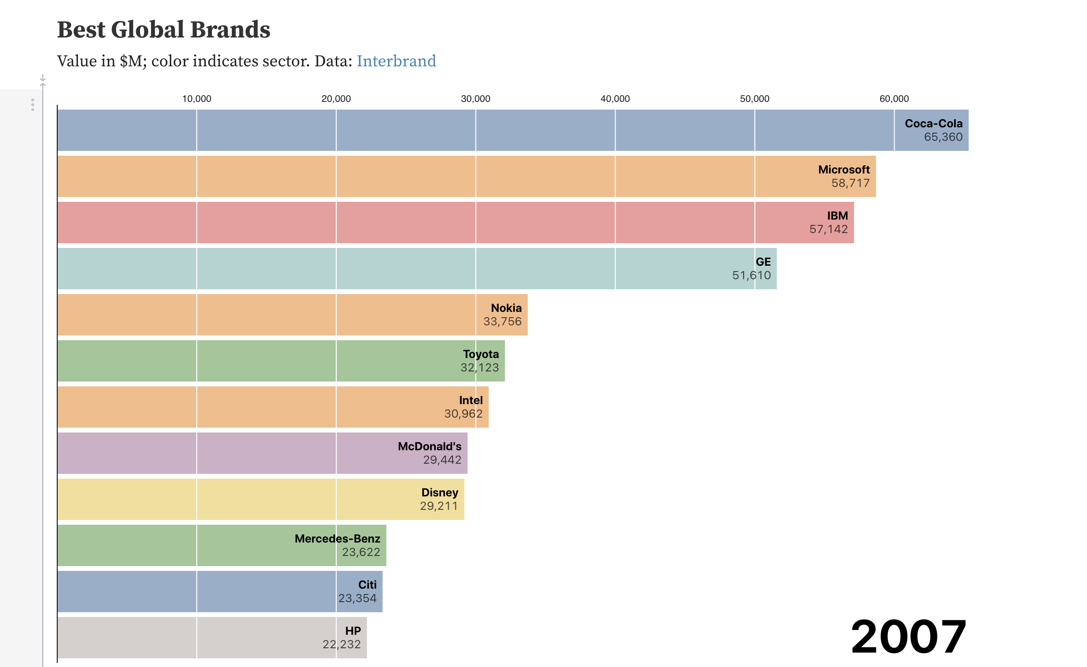

**Expected Outcomes:**

Although there are multiple websites with graphical demonstrations of COVID-19, our practices will enable us to utilize the techniques we learned in the class. We will also show initiatives by creating the bar chart race at state level, which has not been created elsewhere to the best of our knowledge.